bermudagrass
Cynodon dactylon (L.) Pers.
Plant Symbol = CYDA

Contributed by: USDA NRCS Plant Materials Program
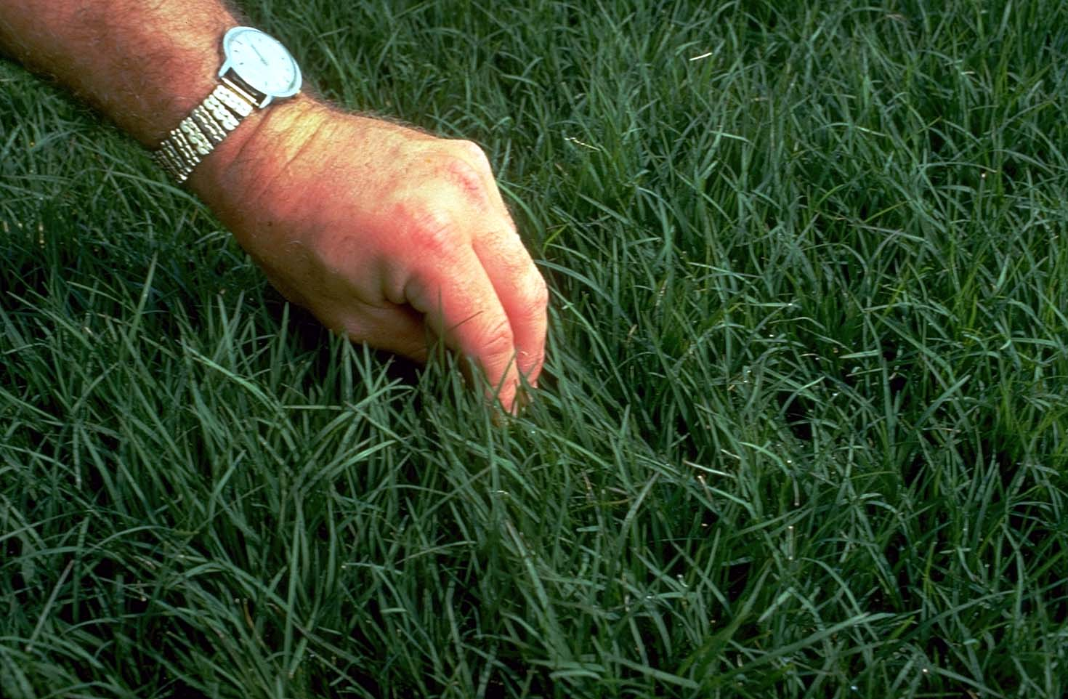

USDA NRCS National Plant Materials Center

Beltsville, MD

Caution: This plant is considered noxious in several states and invasive by several sources. Please check the Noxious and Invasive portion of PLANTS for additional information. Please consult with your local resource specialist prior to using.

Uses
Erosion control: Bermudagrass is used for critical area planting (including channels and pond banks), grassed waterways, and vegetated flumes.

Turf: This grass is suitable for lawns and public areas, and is recommended for problem soils and heavy traffic areas.

Livestock: Bermudagrass provides fair to good pasture and hay with proper management. Forage quality is dependent on soil fertility and stage of growth.

Wildlife: Bermudagrass has forage value for deer, geese and ducks in open, sunny areas.

Recreation: Turf types of the grass form attractive, traffic-resistant, weed-free, and low maintenance ground covers for areas with half to full day sun.

Status
Please consult the PLANTS Web site and your State Department of Natural Resources for this plant’s current status (e.g. threatened or endangered species, state noxious status, and wetland indicator values).

Weediness
This plant may become weedy or invasive in some regions or habitats and may displace desirable vegetation if not properly managed. Please consult with your local NRCS Field Office, Cooperative Extension Service office, or state natural resource or agriculture department regarding its status and use. Weed information is also available from the PLANTS Web site at plants.usda.gov.

Description
Bermudagrass, is of probable Asian origin and was documented as an important grass in the United States by l807. It is a long-lived, warm season perennial that spreads by rhizomes, stolons, and seed. Stems are leafy, branched, and 4 to 6 inches tall. Under favorable conditions, stems may be 12 to 18 inches high. Stems are short jointed. Leaves are flat and spreading. The ligule is a circle of white hairs. Leaves may be hairy or smooth. Seedheads are usually in one whorl of 3 to 7 spikes, each about 1 to 2-1/2 inches long. Some robust forms may have up to 10 spikes in 2 whorls.

Adaptation and Distribution
Although a few hardy strains of Bermudagrass persist in areas with sub-zero winter temperatures, it has achieved importance only in areas of relatively mild winters. Once established on moderately deep to deep soils, Bermudagrass maintains dense sod, non-irrigated, with 16 inches of rainfall. It can withstand sedimentation and long periods of inundation. It prefers full sun and can grow rapidly at air temperatures exceeding 100°F.

Bermudagrass prefers deep soils but produces well on moderately shallow sites under irrigation and good management. It persists on poor soils but require high nitrogen levels for best appearance. It withstands pH ranges from about 5.0 to 8.5 and is boron tolerant. It tolerates saline soils with up to 18 millimhos of electrical conductivity in the soil solution.

Bermudagrass is distributed throughout the majority of the United States. For a current distribution map, please consult the Plant Profile page for this species on the PLANTS Website.

Establishment
Stands may be established by use of seed, sprigs, or plugs planted during mid-spring to mid-summer followed by frequent applications of fertilizer and water. Early planting is most important in areas of marginal adaptability.

Beds for seeding or planting should be firm, smooth, and free of weed seed. For turf plantings, absolute smoothness is necessary for close mowing following establishment. Seed, sprigs, or plugs should be placed into moist soil.

For pasture or hay, drill 3 pounds pure live seed per acre at 1/2 inch depth or less. For turf, use 10 pounds of seed per acre. Higher seeding rates are advisable if seed must be broadcast. If using sprigs, broadcast by hand or with hydro-equipment. Punching and irrigation, if needed, must be done immediately following spreading to keep the sprigs from drying out. Surface soil moisture must be kept high while roots and shoots develop at the sprig nodes.

Fifteen bushels of sprigs per acre disk punched or covered with 1-1/2 inches of soil followed by irrigation as needed ordinarily gives fully established stands in one growing season. On saline soils planting in the side of furrows is desirable so salts will accumulate on the ridges above grass rows.

Use of sod rolls or plugs cut from sod is often a preferred method of establishing turf-type Bermuda on critical sites. Plugs of 3 inch diameter planted on 15 to 18 inch centers will ordinarily establish complete cover in 1 growing season with adequate fertilizer, moisture and half-day to full sun. Complete sodding is preferred for very critical areas or where immediate foot traffic is contemplated. Care immediately following planting is less critical on plantings of sod or plugs than turf-type sprigs.

Management
High quality turf will require frequent very low mowing, fertilizer, and water for vigorous growth. Clippings must be removed. A sharp reel-type mower will avoid unsightly scalping. Good to fair quality turf can be maintained on short water and low fertilizer schedules, thereby reducing mowing frequency.

Bermudagrass will persist as a weed-free ground cover on soils of moderate to high water-holding capacity. Where desirable and permissible, mid-winter controlled burning can be used to reduce thatch. Most herbicides used at recommended rates with reasonable care can be used to control undesirable plants without destroying fully established Bermudagrass. Applications of nitrogen every 2 to 5 years will be needed to maintain vigorous stands on most sites.

Both pasture and hay require good rainfall and heavy fertilizer application for high yield and quality. Thirty to forty pounds of nitrogen should be applied in split increments for each ton of anticipated dry forage yield. Highest yields are obtained on good soils in areas of high average annual temperature with ample water. Harvest or graze at 3 to 4 week intervals for best yields of total digestible nutrient and protein.

Pests and Potential Problems
Several white grubs are known to feed on the root system, however they are normally not a major pest.

Cultivars, Improved, and Selected Materials (and area of origin)
‘Santa Ana’, ‘Tifway’, ‘Tifgreen’, ‘Tifdwarf’, ‘Tufcote’, ‘Brazos’, ‘Quickstand’, ‘Coastal’, ‘Coastcross-1’, and ‘Midland’. All form dense, fine-textured, weed-free sods and tolerate drought, close mowing and heavy traffic, even on problem soils. Seeds, springs, and sod are all commercially available.

Control
Please contact your local agricultural extension specialist or county weed specialist to learn what works best in your area and how to use it safely. Always read label and safety instructions for each control method. Trade names and control measures appear in this document only to provide specific information. USDA, NRCS does not guarantee or warranty the products and control methods named, and other products may be equally effective.

Prepared By & Species Coordinator:
USDA NRCS Plant Materials Program

Edited: 10Aug2000 JLK; 05jun06 jsp

For more information about this and other plants, please contact your local NRCS field office or Conservation District, and visit the PLANTS Web site<http://plants.usda.gov> or the Plant Materials Program Web site <http://Plant-Materials.nrcs.usda.gov>

The U.S. Department of Agriculture (USDA) prohibits discrimination in all its programs and activities on the basis of race, color, national origin, sex, religion, age, disability, political beliefs, sexual orientation, and marital or family status. (Not all prohibited bases apply to all programs.) Persons with disabilities who require alternative means for communication of program information (Braille, large print, audiotape, etc.) should contact USDA's TARGET Center at 202-720-2600 (voice and TDD).
To file a complaint of discrimination write USDA, Director, Office of Civil Rights, Room 326-W, Whitten Building, 14th and Independence Avenue, SW, Washington, DC 20250-9410 or call 202-720-5964 (voice or TDD). USDA is an equal opportunity provider and employer.
Read about Civil Rights at the Natural Resources Convervation Service.

